

SYSTEM TEST PLAN

TECH SELECTOR

Author: Daksh Jasani  
Project Manager: Aayushi Shah  
Date: 12/2/21

**Table of Contents**

INTRODUCTION 3

TESTING SCOPE 3

TESTING OBJECTIVES 3

Features to be Tested 3

Features not to be Tested 4

TEST PROCESS DEFINITION 4

Test Process Phases and Tasks 4

Deliverables 5

APPROACH TO SYSTEM TESTING 5

Approach to Functional Testing 5

ENTRY/EXIT CRITERIA 6

Entry Criteria 6

Exit Criteria 6

ENVIRONMENTAL NEEDS 6

ROLES AND RESPONSIBILITIES 7

TEST CYCLES AND SCHEDULE 8

RISKS AND CONTINGENCIES 8

# INTRODUCTION

This document describes the System Test Plan that provides a common understanding among the “Tech Selector” project stakeholders on the scope, objectives, and approach to performing the system testing. Also, the document explains the features to be tested, testing entry/exit criteria, resource and responsibilities, and testing schedule.

# TESTING SCOPE

The testing scope includes two perspectives - the functional scope and technical scope.

The functional scope includes the following modules of the “Tech Selector” system: User Experience and Payment and User Registration/Login.

The technical scope includes the following architectural components:

* Web browser
* Application server
* Database server

# TESTING OBJECTIVES

The primary focus of this System Test Plan is functional testing with the objective to evaluate the system implementation stability. The non-functional testing requires some special tooling to monitor performance characteristics, which is not available on this project.

The basis for developing functional tests and evaluating the system functionality includes the following sources:

* Business Requirements Document (BRD)
* User Stories (functional requirements)
* Requirements Composition Table (supplementary requirements)

## Features to be Tested

This section lists all core features that will be tested grouped by the application modules below.

User Account

* Create Account
  + To test whether the user is successfully able to create a new account or not.
* Sign into Account
  + To test whether the user has successfully created an account and can login into their account.

Besides the core features in the scope of testing, the function testing also will cover crosscutting concerns that are applicable to the context of the individual core features (refer to the RCT).

## Features not to be Tested

As mentioned above, system performance will not be tested for the lack of required tools. Also, usability and security will not be tested as well.

# TEST PROCESS DEFINITION

## Test Process Phases and Tasks

The test process consists of five phases, which include test planning, design, preparation, execution, and reporting. Each phase has a few tasks as defined below:

* Test Planning
  + Define scope and objectives of testing
  + Define roles and responsibilities
  + Define testing approach
* Test Design
  + Identify test ideas, define an approach to designing test cases
  + Develop test case specifications
  + Measure test coverage
  + Determine requirements for test data
* Test Preparation
  + Setup a test environment
  + Provision test data
  + Install the software in the test environment
* Test Execution
  + Execute all test cases
  + Find and report software defects
  + Evaluate the system stability
  + Validate all target features
* Test Reporting
  + Summarize and report the test execution results
  + Report defect metrics
  + Evaluate the test exit criteria
  + Create a test completion report, submit for stakeholder approval
  + Obtain stakeholder signoff on system testing

## Deliverables

On this project, the test process deliverables include:

* System Test Plan document
* Test Design specifications
* Test Case specifications
* Software Defects
* Test Execution Logs
* Test Completion Report

# APPROACH TO SYSTEM TESTING

## Approach to Functional Testing

The overall approach to functional testing will be based on the Black-box method:

* Test cases will be designed using some formal black-box techniques such as boundary-value analysis, equivalent-class partitioning, cause-effect graphing, decision tables, and state-transition testing, where applicable.
* Test execution will be conducted manually, from the user perspective and based on formal test case specifications.

The test execution results will be captured and reported in test execution logs.

# ENTRY/EXIT CRITERIA

This section defines both Entry and Exit Criteria for test execution and is intended to establish a common understanding about the conditions when the test execution can start and when it can stop.

## Entry Criteria

The test Entry Criteria include the following items:

* The application build is produced and deployed to the test environment
* The system test plan is produced and approved
* The test environment is ready for testing
* Test Designs and test case specifications are completed

## Exit Criteria

The test Exit Criteria include the following items:

* All test cases have been executed
* Zero defects of Critical and Hi-severity remain open
* Open defects of Medium and Low severity have known workarounds
* Test Summary report is produced and published

# ENVIRONMENTAL NEEDS

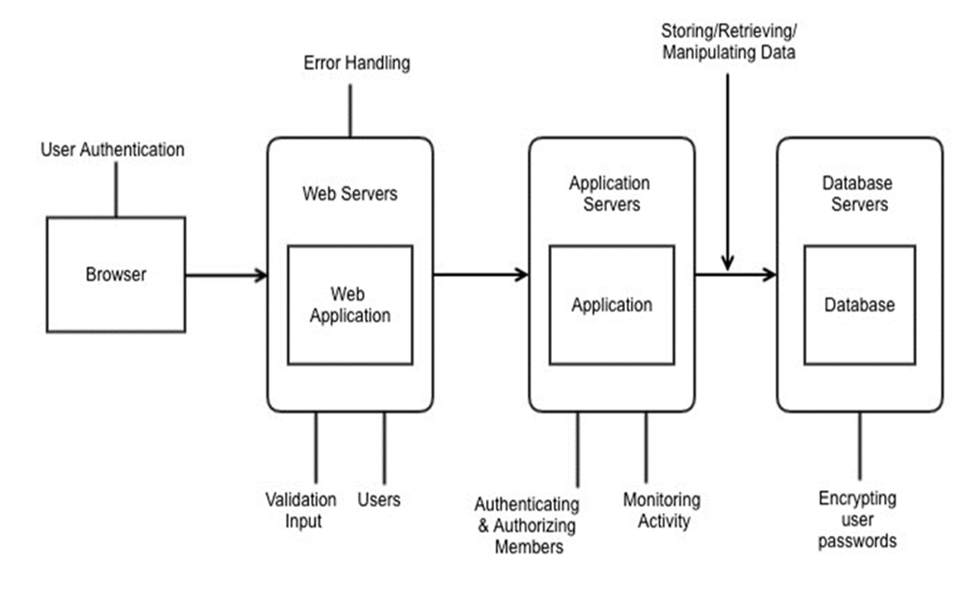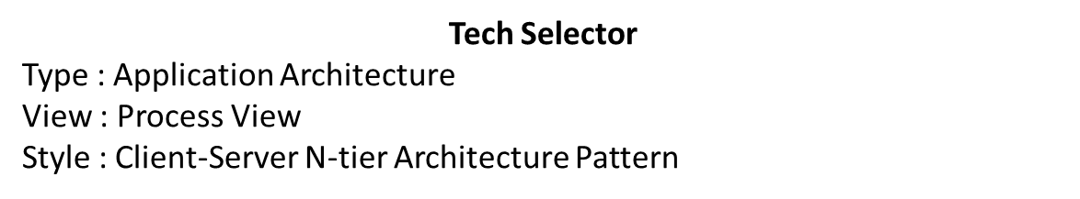The Test Environment should be available to start test execution. It includes a laptop with virtual machine running the web server and database, and internet browsers (Chrome, Firefox, Internet Explorer and Safari) to access the application. The architecture of the test environment is shown below.

# ROLES AND RESPONSIBILITIES

The project team has seven members that are assigned various project roles including Project Manager, Product Owner, Lead Business Analyst, Lead Developer, DBA, Lead QA Analyst. Their responsibilities are defined in the table below.

|  |  |
| --- | --- |
| **Project Role** | **Role Responsibilities** |
| Project Manager | Reviewing and approving the System Test Plan, test design specifications.  Managing the test environment preparation.  Tracking the testing schedule and results. |
| Lead QA Analyst | Designing a test plan, establishing a test repository, developing test case specifications, executing testing and reporting defects. |
| Product Owner | Contributing to the test plan and test case specifications. Reviewing test results. |
| Lead Business Analyst | Contributing to the test plan and test case specifications. Reviewing test results. |
| Lead Developer | Establishing and maintaining the test environment, assisting a Lead QA Analyst throughout the testing process. |
| DBA | Assisting the Lead Developer in establishing and maintaining the test environment. |

# TEST CYCLES AND SCHEDULE

The system test execution will be conducted as two test cycles that are aligned with three application modules as follows:

Cycle 1. User Experience I

* This cycle concentrates on testing the first part (creating an account) of the User Experience Module

Cycle 2. User Experience II

* This cycle concentrates on testing the second part (Sign into the Account) of the User Experience Module.

See the schedule of the test execution cycles in the project plan.

# RISKS AND CONTINGENCIES

This section highlights a few potential risks and contingencies that maybe happened during the system testing.

* Limited testing resource may result in a delay.
* Any changes on the scope objectives can cause a delay or extra work.
* A large number of defects require a longer time to fix defects and complete testing.
* Lack of collaboration of the team members can have a negative impact on the testing progress.